Commercial Auto insurance has some similarities with personal auto insurance, but the biggest differences is in the number and types of vehicles allowed as well as the types of coverages offered.
Here is an approximation of how the different PL coverages relate to CL coverage types. Note that some items in this table are mutually exclusive like “Combined Single Limit” can take the place of both “Bodily Injury” and “Property Damage”.
Personal Lines | Commercial Lines
Part A – Liability  Bodily Injury  Property Damage  Combined Single Limit | Liability Coverage  Bodily Injury  Property Damage  Combined Single Limit
Part B – Medical Payments | Medical Payments
Part C – Uninsured Motorist  (and/or Underinsured Motorist) | Uninsured Motorist – state specific  (and/or Underinsured Motorist)
Part D – Damage to Your Auto  Other Than Collision  Collision | Physical Damage Insurance  Comprehensive  Specified Causes of Loss  Collision
Notable differences include:
- PL includes the “Part A”, “Part B”, etc because these refer directly to items in the contract.
- The CL auto dec pages have items numbers for each section and these refer directly to the CL Auto contract.
- PL can only be written for a single state. So state differences can be easily accommodated throughout the documents
- CL can be written for multiple states (except MI has to be written by itself) so many of the tables have to allow for these differences by state (e.g. some states combine ‘uninsured motorist’ and ‘underinsured motorist' while others split them apart.)
- The ID Card designs for MI are very similar between PL and CL, however the ID Card designs for other states differ due to the different requirements for commercial cards vs. personal lines
- PL shows all coverages (line and vehicle level) in 1 table per vehicle
- CL shows totals for vehicle coverages in Item 2, but also itemizes coverages/deductibles in Item 3
There are 3 different types of Commercial Auto policies:
- XA = AutoAccel – this policy type is intended to provide mostly minimum required coverages to a large fleet of vehicles at a low cost
- CA = Commercial Auto (aka. BAC = Business Auto Coverage) – this type of policy offers more coverages than an XA policy. This is intended mostly for a fleet, but could also be used for some types of dealers or transportation companies
- CA = Auto Dealers (aka CAD = Commercial Auto Dealers) – this type of policy offers the most options for auto dealers, garages, and transportation companies
The Item numbers shown on each different policy type correspond to the items numbers in the contract for that policy type. The contracts come from ISO, so we are not able to change the item numbers to be the same for the same sections across the policy types. Note that XA is largely a “home grown” offering from Grange so many of the endorsements and other forms are proprietary Grange forms. However, they are usually based on the ISO forms for CA.

Note that for CL Auto, the KY Tax schedule may include both locations and/or vehicles since taxes can need to be applied at either level, depending on the situation. This decision is handled by rating and we just show what we are given.
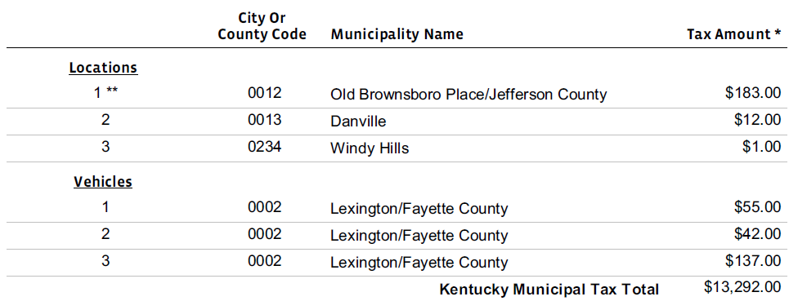
PL Auto does offer the ability to insure a vehicle that is not owned by the customer, but Commercial Auto takes this concept to a new level. There are 3 types of “vehicles” that are not actually vehicles, they are license plates:
- Dealer plates – used by auto dealers when a customer wants to test drive a vehicle
- Transporter plates – these are the trailers that hold the cargo for a large truck
- Registration plates – I actually don’t know exactly what these are, but they are some type of license plate that can be used by different vehicles for whatever reason
None of the above vehicle types would have a VIN since they are not vehicles. On the ID Cards, we just show these without a year/make/model and in the VIN we show “Commercial Fleet”. We do produce 1 card per “vehicle” even though PC can only tell us the number of plates the customer has.
CA also offers the ability to do a “Composite Rated” vehicle type, which is either based on Mileage, Sales or Units. I don’t know a lot about this other than I think it’s used mostly by auto dealers and their exposure is variable due to the nature of auto sales not being guaranteed over the course of a year. Since this is just a “best guess”, composite rated policies are subject to audits and they issue a Premium Audit statement at the conclusion of that audit. Despite being called “Composite Rated”, these policies can only have 1 rating basis at a time.
Lastly but not leastly, all commercial auto policies will generate ID Cards upon issuing a new policy or on a renewal. ID Cards are only generated for new or changed vehicles on an amendment. The ID Cards are included in the entire dec packet issued for the policy and sent to CM/DS this way. There is a second version that is only the ID card PDF and this is also stored in CM/DS.
The ID Card designs can change based on the state of the vehicle. For CA Auto, ID Cards for different states will appear on the same sheet of paper. ID Cards are duplex (front and back.) The front generally contains key identification items: insurance company, agent info, customer name, vehicle year/make/model/VIN (or Commercial Fleet.) The back usually contains whatever cautionary language is required by that state or basic instructions on what to do if you are involved in an accident. There are only 2 states that require 2 cards per vehicle for Commercial: Kentucky and Michigan. The generation of the second card is handled by OTE and is not required of the translation.
There is another type of vehicle ID Card that is specific to Canada. This follows similar rules to the other ID Cards, however we do not issue fleet Canadian ID Cards at this time. (Because it’s not required.) These ID Cards are rarely requested, so they are only available in an “on demand” manner. They are not stored in CM/DS and cannot be mailed directly to the customer via our normal processes. The agent has to give these to the insured. There are no variations in the Canadian ID Cards because they follow the Canadian rules, which do not vary by province. (Whether or not they are required does vary by province.)

